Medina Estuary Houseboats Project

Introduction

The Medina estuary is on the northern coast of the Isle of Wight. It extends approximately 7km from its tidal limit at Newport Harbour to its mouth at Cowes / East Cowes. It has a total area of 219ha, including 101ha of intertidal and 13ha of saltmarsh. The estuary forms part of a network of sites protected under the Habitats Directive for their importance for nature conservation, including the Solent Maritime Special Area of Conservation (SAC), the Solent and Southampton Water Special Protection Area (SPA) and Ramsar site. Part of the estuary is also designated as a Site of Special Scientific Interest (SSSI) and there are various Sites of Importance for Nature Conservation (SINC) on the surrounding land. The Medina estuary also has Shellfish Water Protected Areas.

There are many different inputs of nutrients and faecal bacteria into the Medina estuary from both point and diffuse sources. These combine to raise the level of nutrients and faecal bacteria within the designated sites with an impact on water quality, wildlife and the shellfishery. Potential point source pollution is being investigated and regulated by Southern Water and the Environment Agency but there are other contributing diffuse sources that do not always fall within the regulatory framework or existing projects. The discharge of sewage, or black water, from recreational boating and houseboats has been identified as a potential source of pollution in the Medina.

One of the barriers to reducing sewage discharge into the Medina waterbody is the lack of facilities for houseboats at Newport Harbour. The successful bid to the Catchment Partnership Action Fund (CPAF) has enabled the Estuaries Project and the Isle of Wight Council to help address the impact of sewage discharge into the estuary by creating a new receptacle facility for houseboats at Newport Harbour.

The source of nutrients and faecal bacteria in the estuary is a very complex picture, but this project contributes to the work being carried out to improve the WFD status of the whole waterbody.

The Project Area

The project focussed on an area of quayside that had previously accommodated a toilet /shower facility for harbour users. The facility was removed in 2001 due to misuse and vandalism which led to very high maintenance costs. The area had become a dumping ground and overgrown with scrub. The underground tank was still in place but it was inaccessible and its condition unknown. The project involved site clearance, tank inspection and introduction of an accessible facility to empty portable toilets.
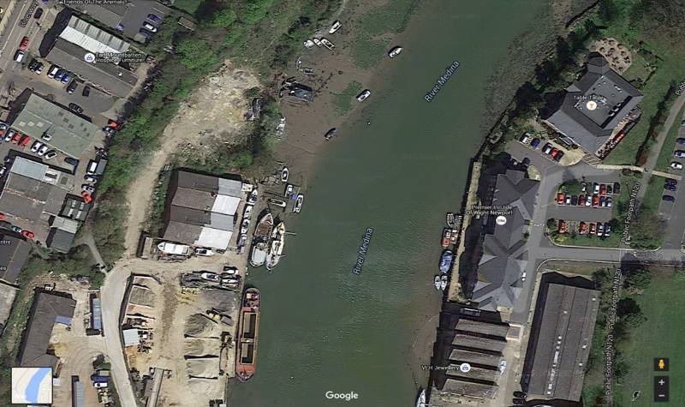

Discussion with houseboat owners
Before the project began the current houseboat owners had been asked about their current method of sewage disposal. Of the houseboats moored alongside Newport Quay, and not within Odessa marine, the majority directly discharged their waste water into the estuary. The owners were also asked about the barriers to changing this practice. The lack of shoreside facilities and the available space and /or cost of retrofitting facilities on board were considered to be the main constraints. There was also a general feeling that the practice was allowable and not a problem due to the flushing effect of the tide.

Land clearance
Before work on the tank could begin the area had to be cleared of scrub and rubbish to ensure safe access and to identify any further work that was required. As part of the project the Isle of Wight Council’s Newport Harbour maintenance team undertook clearance works to remove the vegetation before levelling the ground and securing the site.
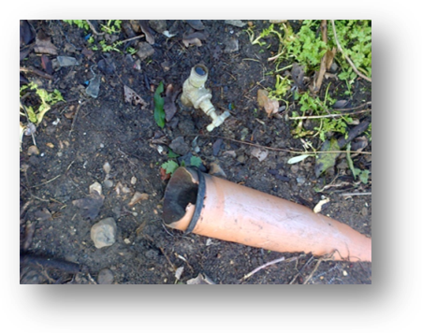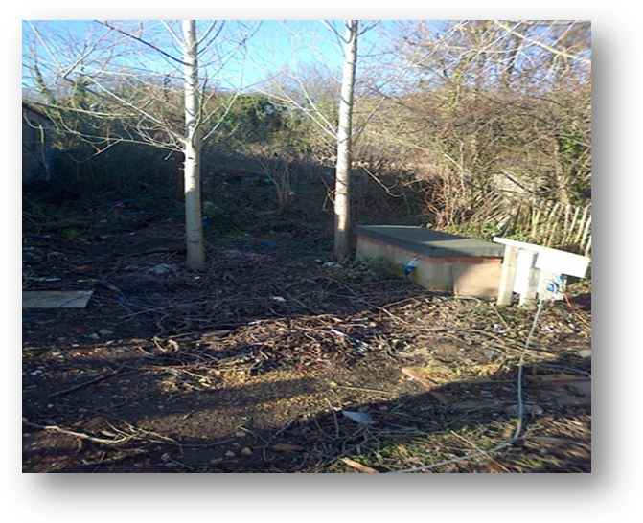
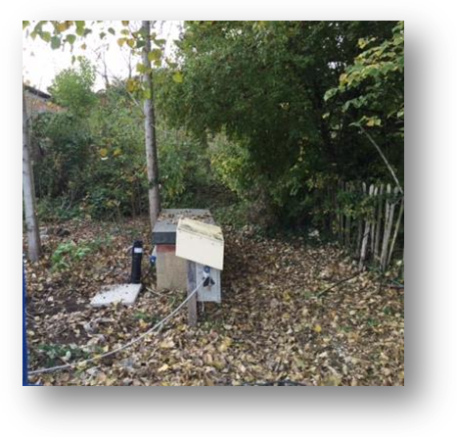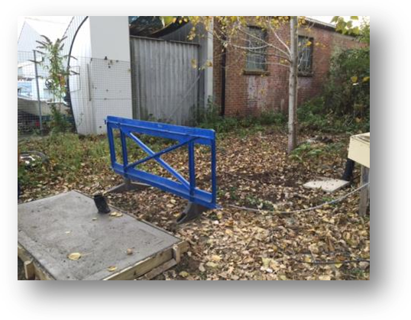

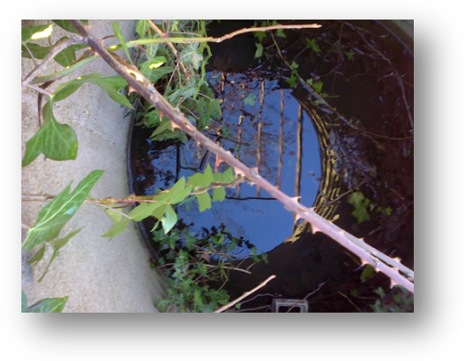

Tank Inspection
Once the site was cleared a specialist contractor was brought in to clean out and inspect the existing holding tank. Debris had entered the tank which had broken the existing digestion and filtering system and some of the pipes. Once empty, the tank was jet washed to facilitate detailed inspection and identify any requirement for repair. The existing pipe work and the mechanism for the soak away were also inspected.
After some delays to the project, due to access issues and the availability of contractors, the tank was eventually found to be intact and of a suitable volume. A plan was then drawn up to improve access with a small secure structure over the receptacle. This was designed to prevent rainwater entering the tank without discouraging use by the boat owners.
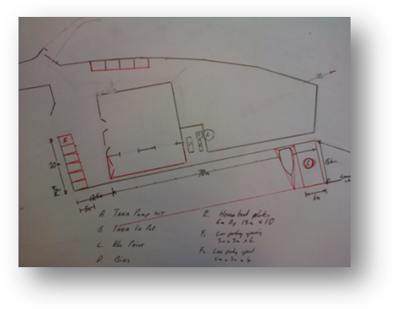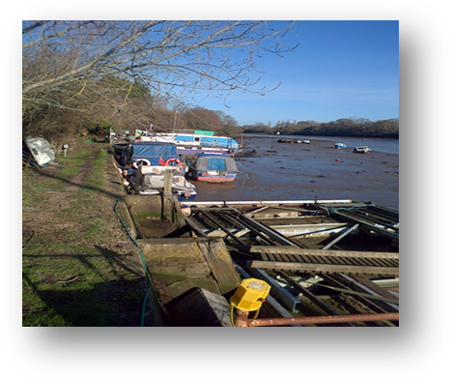

Ground works
Once the plan was developed further ground works were carried out to improve access to the area and to make the tank more accessible. This included the use of geotextile membrane and gravel to reduce the amount of ongoing maintenance without affecting the drainage and absorption capacity of the land. The work also provided a suitable area for refuse and recycling bins for the houseboats. The works also included re-routing and testing the existing electricity and water supplies.

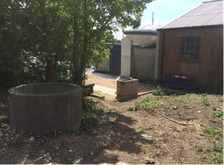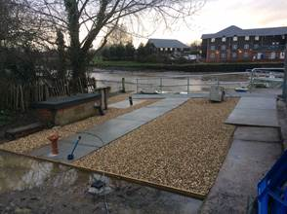

Project Outputs

The work has now been completed and the Harbour Master has opened up the site for more houseboats with the improved facilities. The soak away pipe that had been part of the filtering and digestive system has been blocked off so the tank cannot overflow into the estuary. This may have been a source of discharge into the estuary in previous years. The area features a standalone tank that will be pumped out when required. Electricity, water and recycling facilities on hard standing have also been provided for harbour users. Ongoing maintenance, future inspection and tank emptying are now part of the Harbour’s responsibilities paid for through the harbour dues.

The Isle of Wight Council has developed new terms and conditions for harbour users and set up the Newport Harbour User Group to engage with stakeholders. It is also developing a Harbour Revision Order to improve management capabilities and ensure the long term future of Newport Harbour. Houseboat owners are now more aware of the issues associated with discharge of waster water into the estuary and have easy access to the new facility. In the future any new houseboats will be placed in this area of Newport Harbour and the new regulations will assist ongoing management.

It is hoped that the project has prevented deterioration of protected area objectives, reduced the impact of man-made structures on wildlife in watercourses and reduced the impact of diffuse pollution that arises from urban land use.

